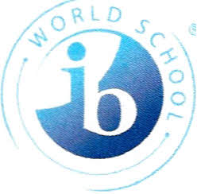

Greetings Langford Parents and Community Partners,
My name is Mrs. King and I have the utmost pleasure of serving as one of the assistant principals at Langford Middle School. I am excited to start another school year. This school year is going to be a journey full of endless possibilities because “We are IB, Going for the Gold!”

Our school’s mission states we are committed to educate our students with quality academics in a safe environment and to be productive citizens in an ever-changing, culturally diverse, and global society. We can only complete this mission with your support as parents and community partners. I am here to serve in whatever way I can to make sure our students and staff have the best school year ever.

To my students, I can not wait to meet you all. I hope that this year will be an experience you will cherish in your years to come.

In closing, please now that my door is always open to you. I heartily welcome conversation and positive input throughout the year. Let us always keep our students the primary focus of our work. I look forward to celebration our collective successes during the 2023-2024 school year.

Sincerely,

Mrs. J. King

